Grazioso Salvare Dashboard README
Created by Adam Gomez
Overview
The purpose of this project was to design and develop a dashboard application for Grazioso Salvare, a company that trains rescue dogs. The dashboard allows users to interact with data from the Austin Animal Center and identify dogs that meet specific criteria for different types of rescue training.
This project follows a full-stack development approach using MongoDB as the database, a Python CRUD module for backend interaction, and a Dash-based web application for the user interface.
The final dashboard provides an intuitive and user-friendly way to filter, view, and analyze animal data.
Dashboard Functionality
The dashboard includes the following key features:
Interactive Filtering
Users can filter the dataset using four options:
- Water Rescue
- Mountain or Wilderness Rescue
- Disaster Rescue or Individual Tracking
- Reset
Each filter applies a MongoDB query that retrieves only the relevant dogs based on:
- Breed
- Sex
- Age range
The Reset option returns all dogs in the dataset.
Interactive Data Table
The data table dynamically updates based on the selected filter. It includes:
- Sorting
- Column filtering
- Pagination
- Row selection
This allows users to easily explore and narrow down results.
Charts
A pie chart displays the distribution of dog breeds for the selected filter.
To improve readability, the chart:
- Shows the top breeds
- Groups remaining breeds into an “Other” category
Geolocation Map
The dashboard includes a map that displays the location of the selected animal using latitude and longitude data.
When a row is selected in the table:
- The map updates to show that animal’s location
- A marker appears with the breed and name
Dashboard Execution Screenshots
The following screenshots demonstrate the functionality of the dashboard and how each filter dynamically updates the data table, chart, and map.
1. Default / Reset View
(Shows all dogs before filtering)
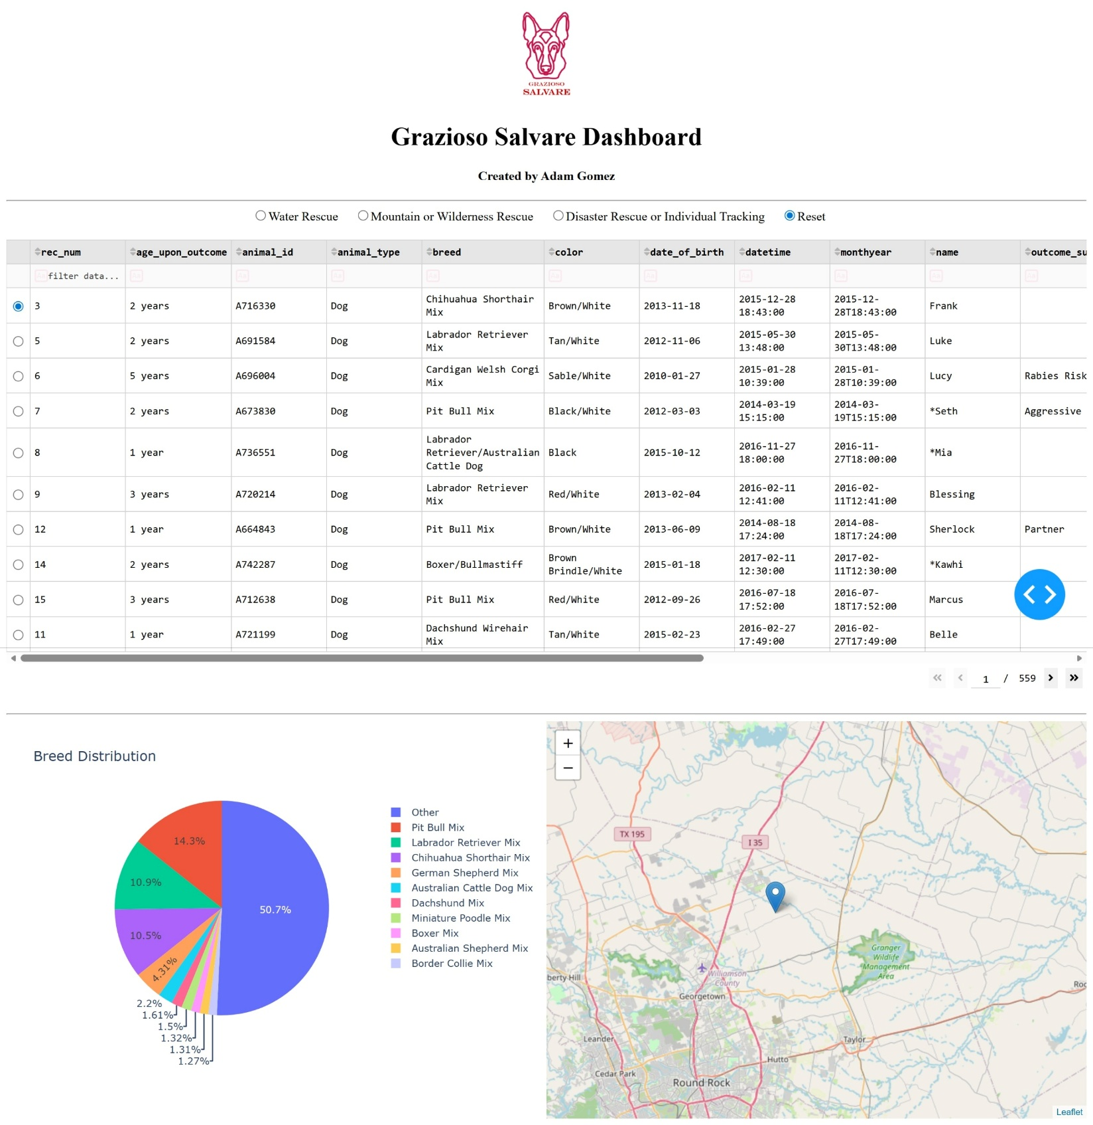2. Water Rescue Filter
(Displays dogs matching water rescue criteria)
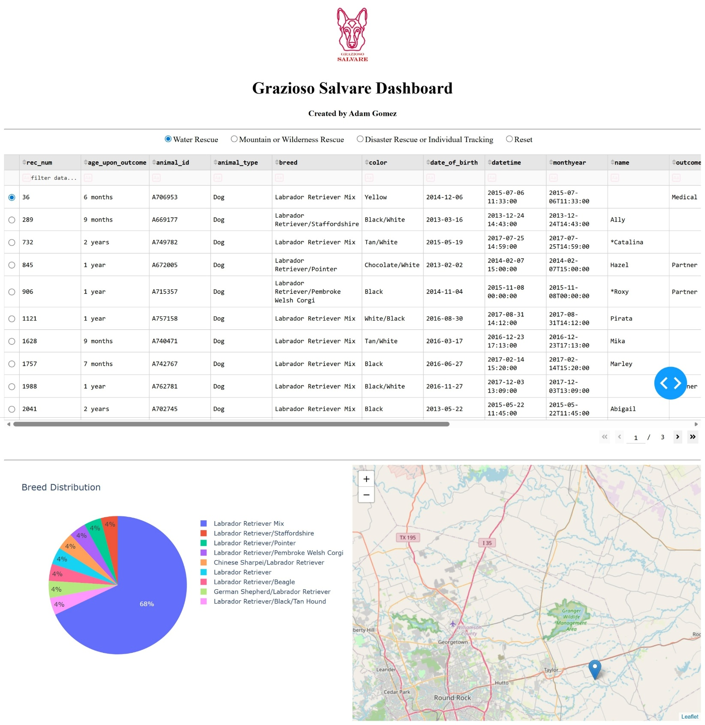3. Mountain or Wilderness Rescue Filter
(Displays dogs matching mountain rescue criteria)
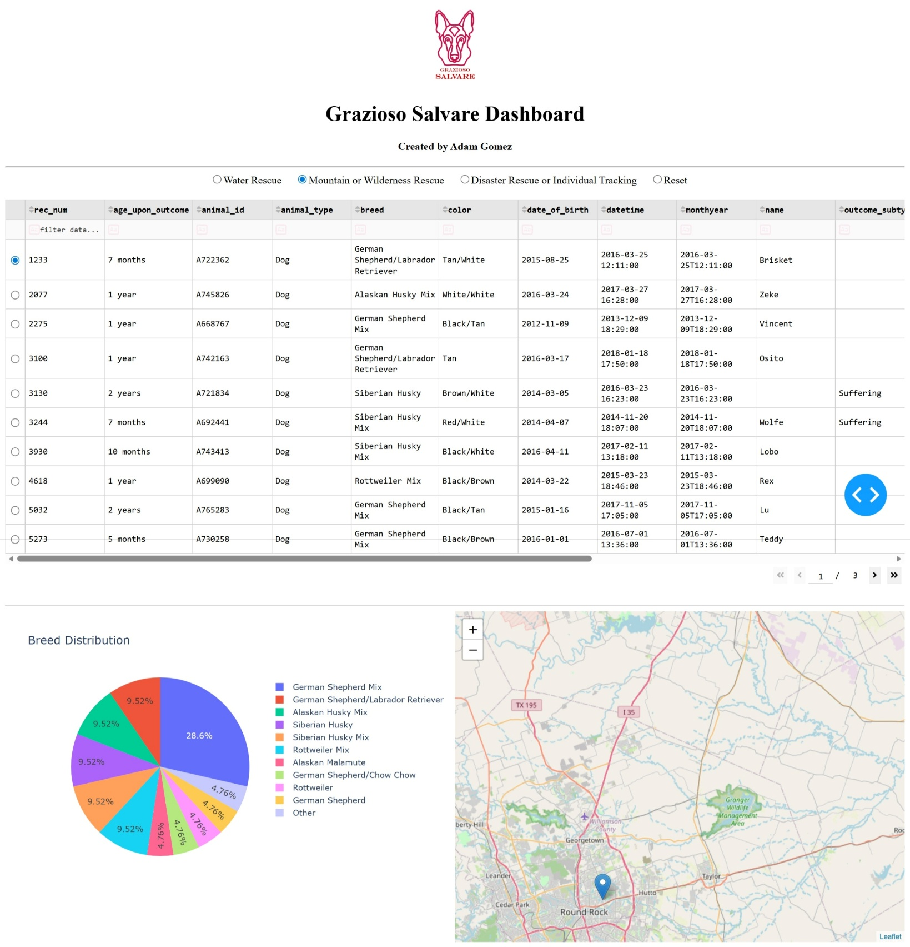4. Disaster Rescue or Individual Tracking Filter
(Displays dogs matching disaster rescue criteria)
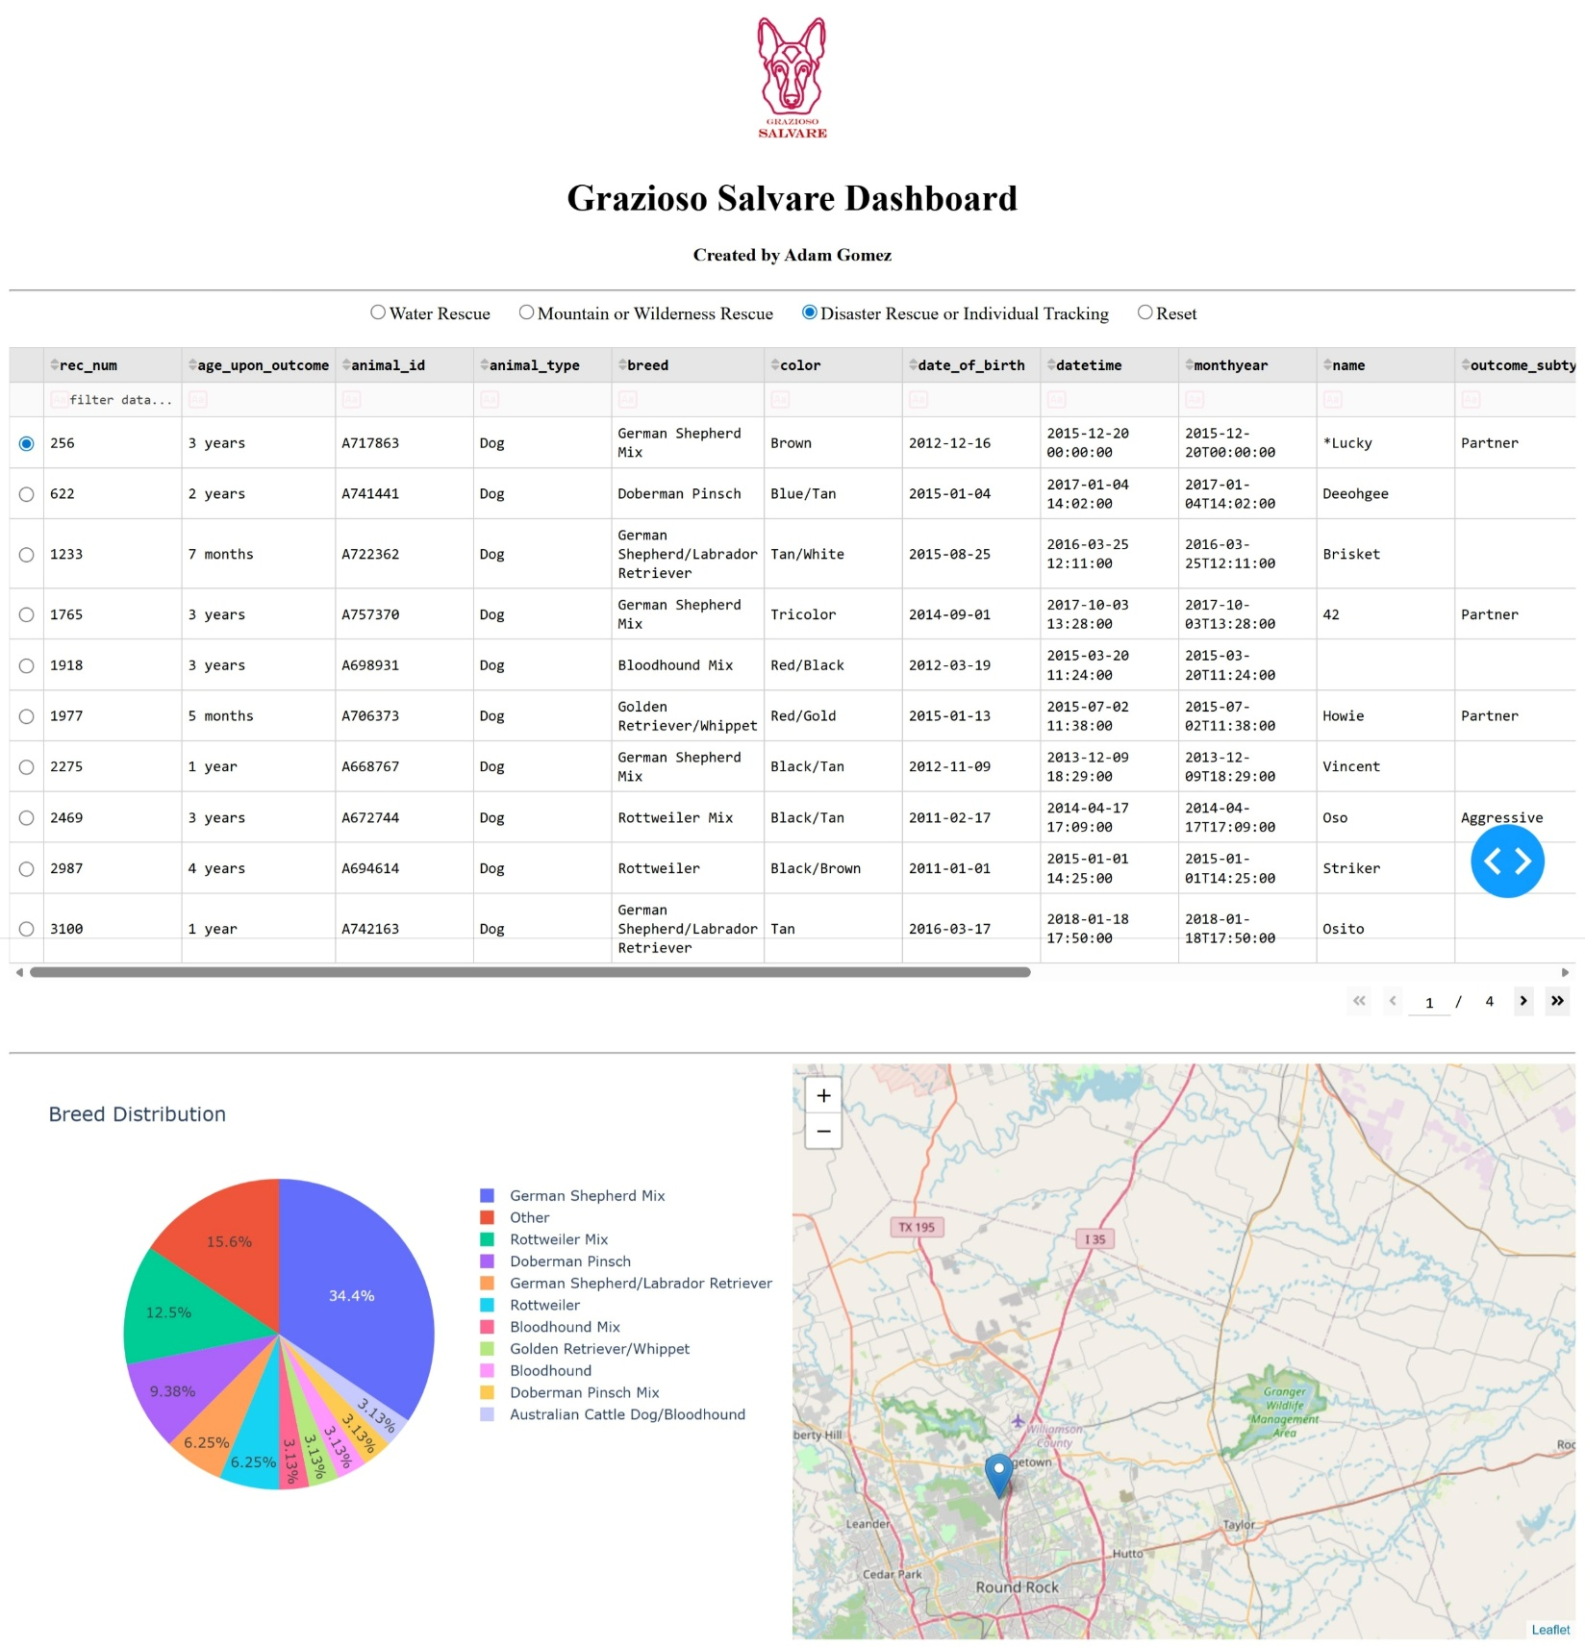5. Reset View (After Filtering)
(Returns dashboard to original unfiltered state)
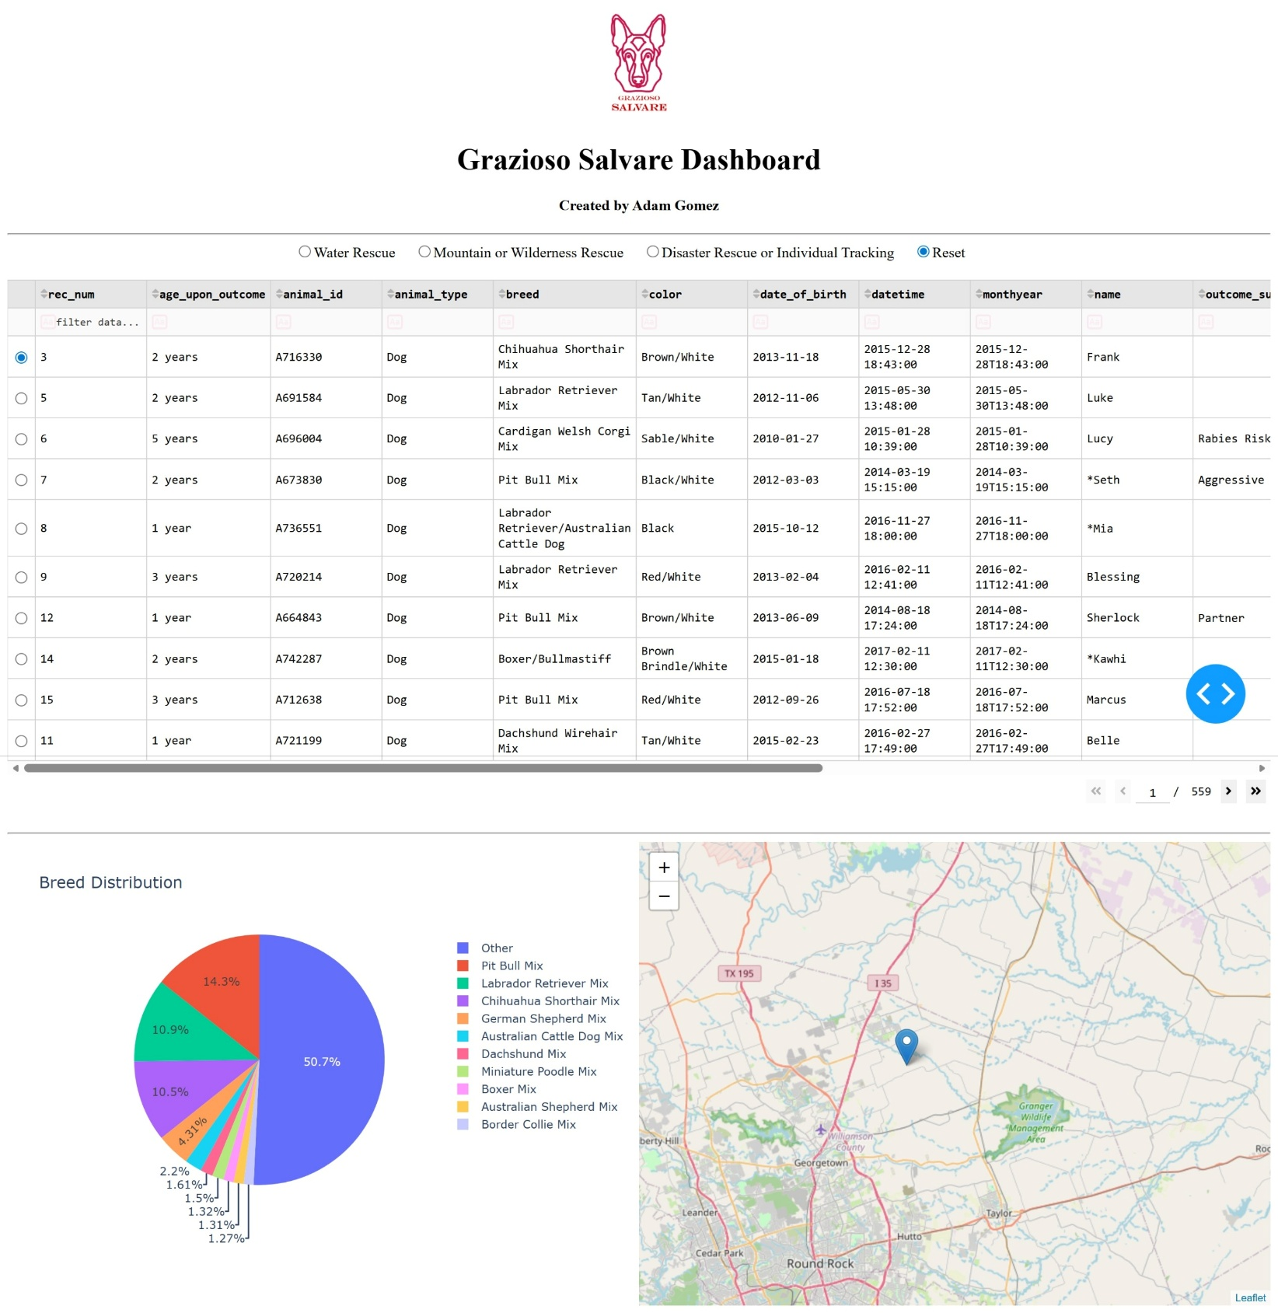Tools and Technologies Used
MongoDB
MongoDB was used as the database for this project because:
- It stores data in a flexible JSON-like format
- It integrates well with Python
- It allows dynamic querying for filtering
MongoDB serves as the Model in the MVC design pattern.
Python (CRUD Module)
A custom Python module (CRUD_Python_Module.py) was developed to handle:
- Create
- Read
- Update
- Delete operations
This module acts as the Controller, managing communication between the dashboard and the database.
Dash (Plotly)
Dash was used to build the dashboard interface because:
- It allows creation of interactive web apps using Python
- It supports callbacks for dynamic updates
- It integrates well with Plotly for visualization
Dash provides the View and Controller functionality.
Additional Libraries
- Pandas for data manipulation
- Plotly Express for charts
- Dash Leaflet for mapping
Steps Taken to Complete the Project
- Created and tested the MongoDB database using the Austin Animal Center dataset
- Developed the CRUD Python module
- Built the dashboard layout using Dash
- Added an unfiltered data table
- Implemented MongoDB filtering queries
- Connected filters using Dash callbacks
- Created a pie chart for breed distribution
- Improved chart readability by grouping smaller categories
- Added a geolocation map
- Included branding (logo and name)
- Tested dashboard and captured screenshots
Challenges and Solutions
Challenge 1: Breed Matching
The dataset contained inconsistent breed naming.
Solution:
Used MongoDB $regex queries to match partial breed names.
Challenge 2: Chart Readability
The pie chart initially had too many categories.
Solution:
Grouped smaller categories into an “Other” category.
Challenge 3: Dataset Relevance
The Reset filter initially returned all animals.
Solution:
Limited results to dogs only to match project requirements.
How to Run the Project
- Ensure MongoDB is running locally
- Load the dataset into the aac database
- Place the following files together:
  - ProjectTwoDashboard.ipynb
  - CRUD_Python_Module.py
  - Grazioso Salvare logo image
- Open the notebook in Jupyter Lab or Codio
- Run all cells
- Launch the dashboard
Conclusion
This project demonstrates how database systems, backend logic, and frontend design can be integrated into a functional application. The dashboard provides a clear and interactive way to filter and analyze animal data, helping Grazioso Salvare identify suitable rescue dogs.

